**Dong, Arunachal Pradesh**

**History**-Dong is a small village in Dong valley of Anjaw district, Arunachal Pradesh, India. It is the easternmost village in the India, near the point where India, China and Myanmar meet .

**Location**- Dong lies at the junction of the [Lohit River](https://en.wikipedia.org/wiki/Lohit_River" \o "Lohit River) and the Sati (or Sai Ti) stream at an elevation of 1,240 metres (4,070 ft). The village can be reached on foot from [Walong](https://en.wikipedia.org/wiki/Walong" \o "Walong) in a 30-minute climb.

**Attraction**-The place is enriched with unspoilt natural beauty and is a photographer’s paradise. Trekking is the best way to explore this gorgeous destination.

tourists climb up to at 3 am to see the sun rise

**Best time to visit-**Dong can be ideally visited during **summer months** (April to July).

**Vlog**-https://www.youtube.com/watch?v=In9S4ujC09s

1st image:

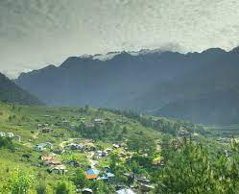

https://i.pinimg.com/originals/99/10/4b/99104b0c59c86724aa3c6bef592d2d9f.jpg

2nd image:

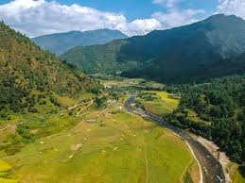

<https://images.unsplash.com/photo-1589808015717-a626de258af0?ixid=MnwxMjA3fDB8MHxzZWFyY2h8MXx8YXJ1bmFjaGFsJTIwcHJhZGVzaCUyQyUyMGluZGlhfGVufDB8fDB8fA%3D%3D&ixlib=rb-1.2.1&w=1000&q=80>